Main report

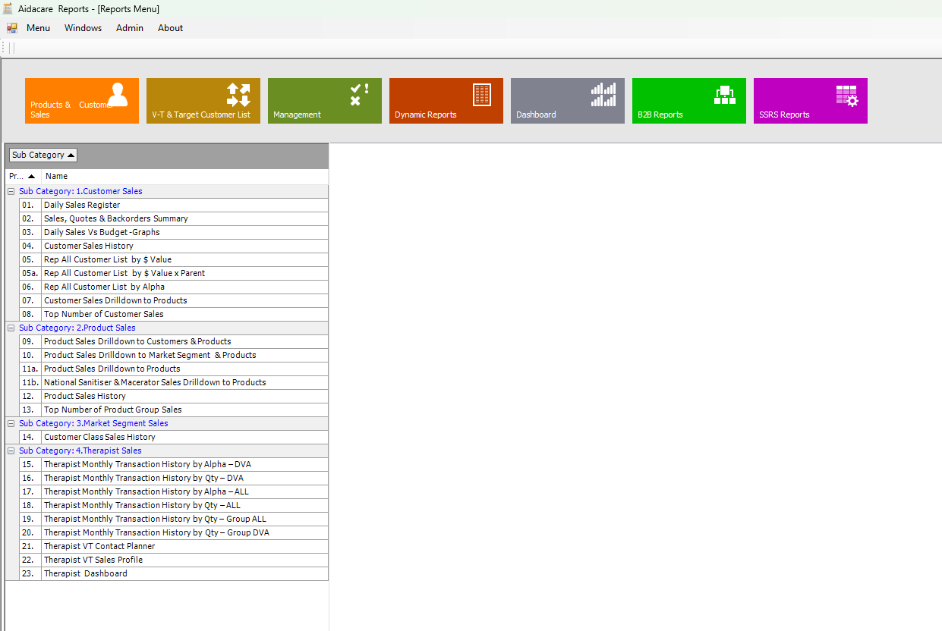
List of reports under a selected category
System menu (dynamics)
Report categories (dynamics)

Menu: admin contain 2 sub menu – users and Reports
Menu users: the user access can be restricted based on geographical and user role etc, etc as discussed .
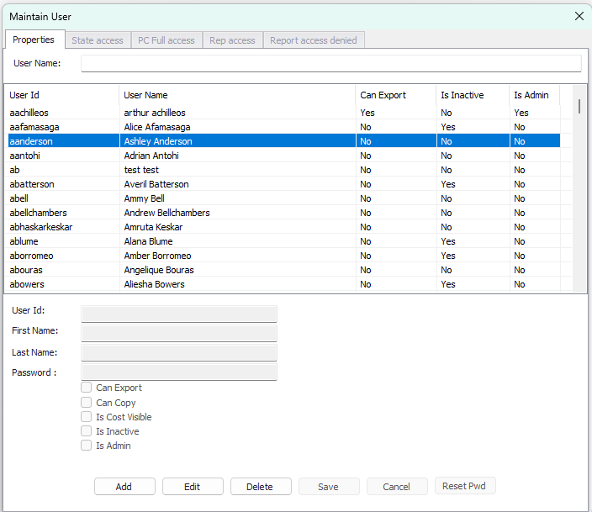
Menu: Reports -list and maintain
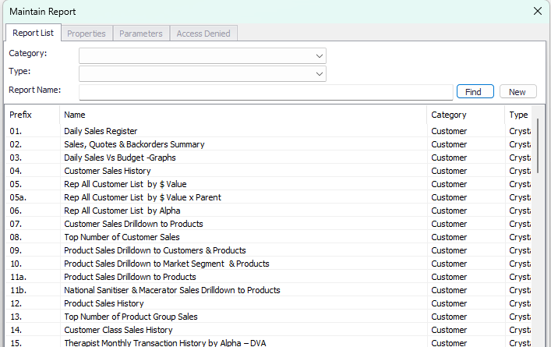

Report properties
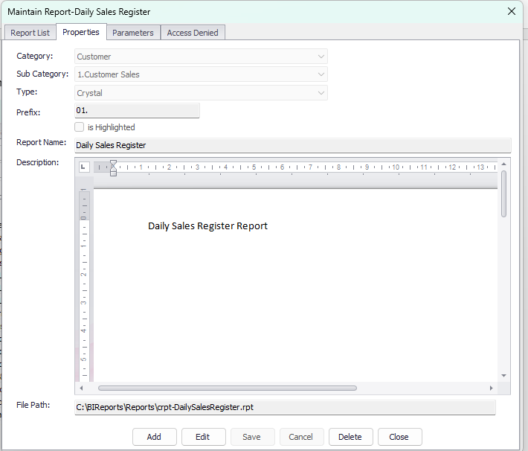

Report parameter /filters
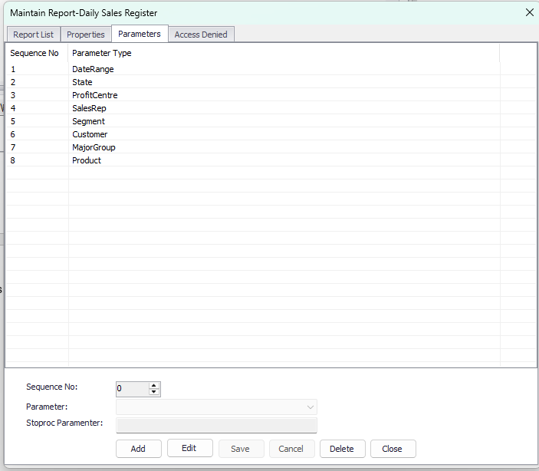

Parameter for selections
All possible parameters/filters should be included in this form and visible when the report parameter is selected for a specific reports .

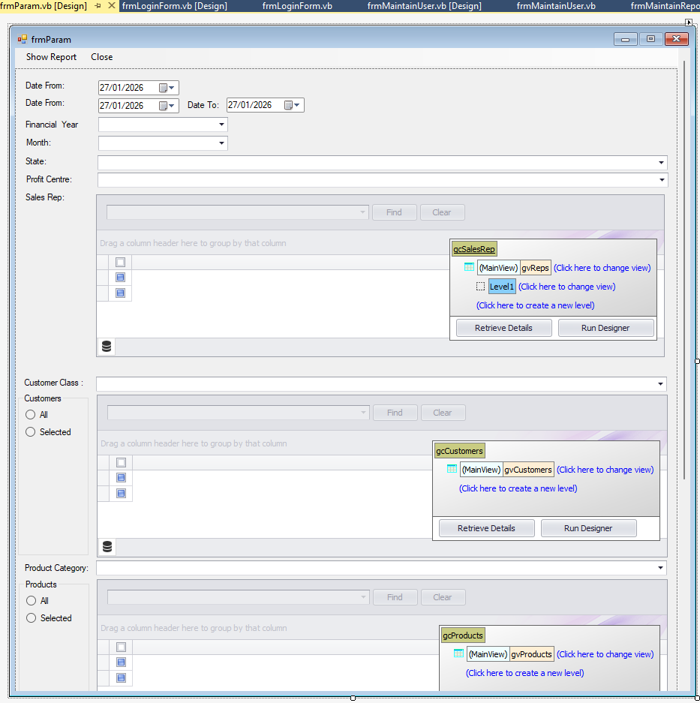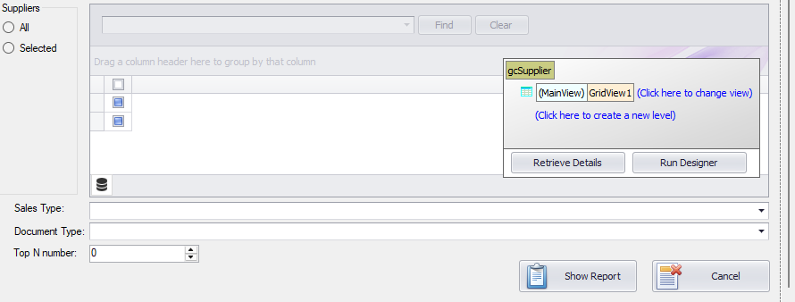

Parameter form when running a specific report based on the parameter assigned to the report/query
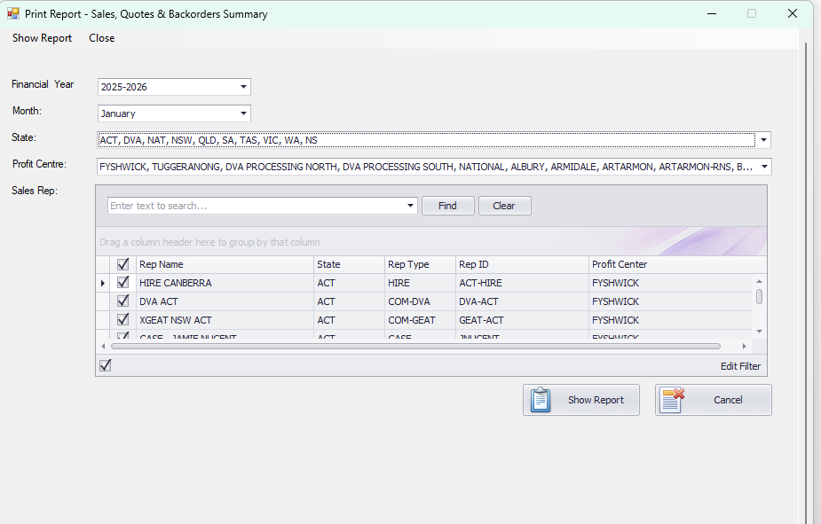
The report will be shown when the user click on show report by applying the selected parameter by the user .

